# ***A Deep Learning Based Approach towards Medical Image Analysis with X-Ray and Endoscopy***

# Abstract

This research centers on the application of deep learning techniques in the realm of medical image analysis, specifically focusing on the segmentation of gastrointestinal polyps and the categorization of chest X-ray images. The image classification task employed the Chest X-ray images dataset, while image segmentation utilized the Kvasir-SEG dataset. The methodology incorporated a convolutional neural network (CNN) for image classification and the U-net model for image segmentation. Notably, both the image classification and segmentation processes demonstrated exceptional levels of accuracy and precision in their outcomes. The significance of this study lies in its potential impact on advancing medical diagnosis, leading to more accurate and effective diagnostic procedures for enhanced patient care. To further enhance the accuracy and precision of future medical image analysis endeavors, emphasis should be placed on expanding datasets and implementing advanced deep learning algorithms.

# Introduction

Medical Image Analysis, a field at the intersection of healthcare and technology, involves the utilization of computational techniques to examine and interpret images generated by various medical imaging modalities, including X-rays, CT scans, MRI, and ultrasound. In recent times, the application of medical image analysis using X-ray and endoscopy has emerged as a pivotal component in the healthcare landscape, demonstrating significant potential to revolutionize patient care and diagnosis.

By leveraging sophisticated algorithms and machine learning methods, medical image analysis serves as a valuable tool for healthcare professionals. Its applications extend to crucial tasks such as disease diagnosis, treatment planning, and continuous monitoring of patient health. The integration of advanced technologies not only enhances the accuracy and efficiency of medical diagnostics but also contributes to the evolution of personalized and data-driven healthcare solutions.

The objectives of this medical image analysis capstone project, with a specific focus on X-ray and endoscopy data, are rooted in addressing pertinent research questions and achieving meaningful outcomes. The project seeks to go beyond theoretical exploration and actively contribute to the existing body of knowledge in the field. Furthermore, it aims to develop practical solutions that can be seamlessly integrated into healthcare practices, leveraging the power of data science and technology.

In essence, this project is driven by a dual commitment – advancing the understanding of medical image analysis in the context of X-ray and endoscopy data and translating this understanding into tangible solutions that address critical healthcare challenges. By harnessing the capabilities of data science, this endeavor aspires to foster innovations that have a lasting impact on patient outcomes and the broader landscape of healthcare diagnostics.

# Motivation Examples for the Medical Image Analysis Capstone Project:

Enhancing Diagnostic Accuracy:

The motivation for this project stems from the imperative to enhance diagnostic accuracy in medical imaging. By applying advanced algorithms to X-ray and endoscopy data, the project aims to provide healthcare professionals with more precise and reliable tools for disease detection.

Improving Patient Care:

The primary motivation is to contribute to the improvement of patient care through innovative medical image analysis. By developing solutions that assist in disease diagnosis and treatment planning, the project seeks to positively impact patient outcomes and overall healthcare quality.

Addressing Healthcare Challenges:

The project is motivated by a commitment to addressing critical challenges in the healthcare industry, particularly those related to medical imaging modalities. The goal is to leverage data science and technology to create practical solutions that alleviate existing challenges and streamline healthcare processes.

Advancing Personalized Medicine:

Personalized medicine is at the forefront of modern healthcare, and the project is motivated by a desire to contribute to this paradigm shift. By tailoring medical image analysis to individual patient needs, the project aims to support the realization of personalized and targeted treatment plans.

Harnessing Technological Innovation:

The rapid advancements in technology provide an exciting opportunity to revolutionize medical diagnostics. The project is motivated by the desire to harness these innovations, including machine learning and data science, to develop cutting-edge solutions that align with the evolving landscape of healthcare.

Contributing to Research and Knowledge:

Motivated by a commitment to advancing scientific knowledge, the project seeks to contribute to the research literature in medical image analysis. By addressing specific research questions, the project aims to fill gaps in understanding and potentially pave the way for future breakthroughs in the field.

Empowering Healthcare Professionals:

Healthcare professionals can benefit significantly from tools that streamline and enhance their workflow. The motivation behind this project is to empower healthcare professionals with advanced image analysis capabilities, enabling them to make informed decisions and provide optimal care to patients.

Data-Driven Healthcare Solutions:

In an era where data is a powerful resource, the project is motivated by the potential to create data-driven healthcare solutions. By leveraging the wealth of information in medical images, the goal is to develop tools that not only assist in diagnosis but also contribute to a more informed and efficient healthcare ecosystem.

# Real-world applications

Real-world applications of medical image analysis, particularly utilizing X-ray and endoscopy data, demonstrate the transformative impact of advanced technologies on healthcare. Here are some tangible examples:

Computer-Aided Diagnosis (CAD):

Application: CAD systems analyze medical images, such as X-rays, to assist radiologists in detecting abnormalities. For instance, CAD can aid in the early detection of lung nodules in chest X-rays, enhancing diagnostic accuracy.

Gastrointestinal Polyp Detection:

Application: Endoscopy images can be analyzed using image segmentation techniques to detect and characterize gastrointestinal polyps. This application assists gastroenterologists in early diagnosis and intervention for conditions such as colorectal cancer.

Fracture Detection in X-rays:

Application: Machine learning algorithms applied to X-ray images help identify and classify fractures. This technology supports orthopedic surgeons in making timely and accurate decisions for patient treatment.

Pneumonia Diagnosis in Chest X-rays:

Application: Chest X-ray analysis is employed for the detection and classification of pneumonia. Machine learning models assist healthcare professionals by providing rapid and accurate assessments of respiratory conditions.

Tumor Segmentation in MRI Images:

Application: Magnetic Resonance Imaging (MRI) data can be analyzed to segment and characterize tumors in various body tissues. This aids oncologists in treatment planning and monitoring the response to therapies.

Endoscopic Lesion Detection:

Application: Endoscopic images are analyzed for the detection of lesions in organs such as the esophagus or colon. Automated lesion detection supports early diagnosis and intervention in gastrointestinal diseases.

Bone Age Assessment:

Application: X-ray images of hand and wrist bones are analyzed to assess bone age in pediatric patients. This is crucial for tracking growth and development and identifying potential abnormalities.

Cardiac Image Analysis:

Application: Medical image analysis is employed in the interpretation of cardiac imaging modalities, such as angiograms or echocardiograms. It aids cardiologists in diagnosing heart conditions and planning interventions.

Colonoscopy Assistance:

Application: Endoscopy image analysis assists in navigating and identifying abnormalities during colonoscopies. This technology aims to improve the efficiency and accuracy of the procedure.

However, detecting pneumonia using Chest X-Ray images and gastrointestinal polyps using Endoscopy images has been discussed elaborately as a part of this project.

# Project Description

The primary objective of this research is to underscore the capabilities of deep learning methodologies in medical image analysis and underscore the importance of accurate and efficient diagnosis through advanced image processing techniques.

In this study, we employed two distinct sets of data, namely Kvasir-SEG and Chest X-Ray Images, to develop two algorithms focusing on techniques of deep Learning namely- image classification and segmentation

Convolutional Neural Networks (CNNs) are instrumental in medical image analysis, addressing image classification and segmentation tasks. For Chest X-Ray image classification, a CNN model, potentially utilizing transfer learning with architectures like VGG-16, is employed. Data augmentation techniques enhance model robustness, contributing to a remarkable accuracy in classifying images as normal, bacterial pneumonia, or viral pneumonia.

In gastrointestinal polyp image segmentation from the Kvasir-SEG dataset, the U-Net architecture is utilized, demonstrates effective pixel-wise classification. The dice coefficient and an intersection over union (IoU) are calculated on the model , to showcase the precise segmentation. Both tasks involve optimizing models with Adam optimizer and specific loss functions, emphasizing the potential of CNNs in advancing medical image analysis for accurate diagnoses and treatment planning.

# Challenges:

Despite the promising applications of deep learning in medical image analysis, several challenges persist in the field. One major challenge is the need for large and diverse datasets, especially in medical imaging where obtaining annotated data can be time-consuming and expensive. Additionally, the interpretability of deep learning models in medical contexts remains a challenge, as clinicians often require transparency in decision-making processes. Ensuring the ethical use of patient data, maintaining privacy, and addressing potential biases in the algorithms are also critical challenges.

# Technical Contributions:

The technical contributions of this research lie in overcoming challenges and advancing the state-of-the-art in medical image analysis. The application of Convolutional Neural Networks (CNNs) for image classification and segmentation represents a significant technical contribution. The utilization of transfer learning, specifically with architectures like VGG-16, enhances the efficiency of the model, especially in tasks such as Chest X-Ray image classification. The implementation of the VC288 model, based on U-Net architecture, demonstrates innovation in pixel-wise segmentation, addressing challenges in gastrointestinal polyp image analysis.

Furthermore, the study makes technical contributions by emphasizing the importance of data augmentation techniques to enhance model robustness and generalizability. The use of specific optimization algorithms like Adam optimizer and tailored loss functions showcases a nuanced understanding of the technical requirements for medical image analysis. These technical contributions collectively underscore the potential for deep learning to revolutionize medical diagnosis and treatment planning, paving the way for future advancements in the field.

# Background

## Related Papers

**Deep Learning for Chest X-ray Analysis: A Survey [1]**

The papers covered in this review collectively explore the application of deep learning techniques to chest radiographs, a critical aspect of medical image analysis. These studies span various tasks, providing a holistic understanding of the capabilities and potential advancements in this domain. Image-level prediction tasks, including classification and regression, are examined to discern the efficacy of deep learning models in diagnosing and predicting medical conditions from chest X-ray images.

Moreover, segmentation studies delve into the precise delineation of anatomical structures or abnormalities within the radiographs. Localization tasks focus on identifying and pinpointing specific regions of interest, contributing to targeted medical interventions. Image generation techniques are explored, showcasing the ability of deep learning to synthesize realistic chest X-ray images.

The review also sheds light on the practical applications of these advancements, detailing commercially available tools that leverage deep learning for chest radiograph analysis. By categorizing and summarizing the diverse research efforts, the paper provides a comprehensive overview of the current state of the art in deep learning-based chest radiograph analysis. The inclusion of potential future directions serves to guide further research, encouraging the ongoing evolution of this impactful field within medical imaging.

<https://www.researchgate.net/publication/350104803_Deep_Learning_for_Chest_X-ray_Analysis_A_Survey>

**State-of-Art Review on Medical Image Classification Techniques[6]**

This paper provides a comprehensive exploration of the complexities inherent in medical image analysis, where the interpretation of pixel-based representations becomes a critical aspect for gaining insights, conducting analyses, and facilitating disease diagnosis. The central focus is on image categorization, a fundamental component in the realm of computer-aided diagnosis, demanding the utilization of advanced techniques to ensure both accuracy and sensitivity.

In tackling these challenges, the paper leverages the outcomes of sophisticated image processing, pattern identification, and classification techniques. The integration of computational results is complemented by the indispensable expertise of medical professionals, forming a symbiotic relationship to enhance the reliability and interpretability of the analysis. The core objective extends beyond achieving high accuracy; it involves the nuanced identification of specific anatomical regions affected by the disease, contributing to a more targeted and precise diagnostic process.

Throughout the paper, the evolution of medical image classification methods takes center stage, offering a retrospective analysis of advancements made over time. This retrospective lens not only highlights the progress achieved in algorithmic precision but also underscores the dynamic nature of classification algorithms in adapting and refining their capabilities in response to evolving requirements and challenges in medical image analysis.

<https://www.researchgate.net/publication/375909345_State-of-Art_Review_on_Medical_Image_Classification_Techniques>

**PolyEffNetV1: A CNN based colorectal polyp detection in colonoscopy images [3]**

This research addresses a critical issue in colorectal cancer prevention by focusing on the early identification of polyps, the root cause of the disease. The complexity arises from variations in polyp size and shape, making their detection in colonoscopy images challenging. The proposed solution, PolypEffNetV1, employs a U-Net for segmentation and EfficientNetB5 for classification, harnessing the power of deep learning algorithms.The segmentation process utilizes colonoscopy images from the KVASIR dataset, containing 1000 images with "ground truth" labeling. For classification, a combination of KVASIR and CVC datasets is integrated, totaling 1612 images with 1696 polyp regions and 760 non-polyp inflamed regions. PolypEffNetV1 demonstrates impressive performance with a testing accuracy of 97.1%, Jaccard index of 0.84, dice coefficient of 0.91, and F1-score of 0.89 in segmentation. The subsequent classification phase, determining whether the segmented region is a polyp or non-polyp inflammation, achieves a validation accuracy of 99%, specificity of 98%, and sensitivity of 99%.

The potential applications of this system are significant, offering gastroenterologists a tool to identify polyps in colonoscopy images or videos. This advancement not only enhances healthcare quality by enabling early diagnosis but also provides flexibility for deployment, allowing real-time assistance at the device edge or integration with existing software applications for offline review and treatment planning.

<https://www.researchgate.net/publication/367349551_PolyEffNetV1_A_CNN_based_colorectal_polyp_detection_in_colonoscopy_images>

## Software Tools

The research project utilized specific software tools for the implementation of its algorithms and analysis. The primary tools employed include:

Jupyter Notebook:

Purpose: Jupyter Notebook serves as an interactive computing environment, enabling the creation and sharing of live code, equations, visualizations, and narrative text. It is widely used in data science and machine learning projects.

TensorFlow:

Purpose: TensorFlow is an open-source machine learning framework that facilitates the development and training of deep learning models. It provides a comprehensive set of tools for building and deploying machine learning applications.

Keras:

Purpose: Keras is a high-level neural networks API written in Python, running on top of TensorFlow. It simplifies the process of building and training deep learning models, making it accessible for researchers and developers.

Labelbox:

Purpose: Labelbox is a data labeling platform that assists in creating labeled datasets for machine learning. It is particularly useful for tasks like image segmentation, where accurate annotations are crucial.

These tools collectively contribute to the successful implementation of the image classification and segmentation algorithms in the medical image analysis project. The combination of Jupyter Notebook, TensorFlow, and Keras provides a robust environment for developing and training deep learning models, while Labelbox aids in the annotation and preprocessing of medical image datasets.

## Required Hardware

GPU (Graphics Processing Unit):

Purpose: Deep learning tasks, especially involving convolutional neural networks (CNNs), benefit significantly from GPU acceleration. GPUs excel at parallel processing, speeding up the training of complex models.

CPU (Central Processing Unit):

Purpose: While the GPU handles the parallelizable tasks in deep learning, the CPU is still essential for overall system coordination and certain non-parallelizable computations.

RAM (Random Access Memory):

Purpose: Sufficient RAM is crucial for handling the large datasets often encountered in medical image analysis. It allows for efficient storage and retrieval of data during model training and inference.

Storage (SSD/HDD):

Purpose: High-capacity and fast storage is essential for storing large medical image datasets and model checkpoints. SSDs are preferred for faster data access.

Networking:

Purpose: For tasks involving large datasets or collaborative research, a robust network connection is crucial for data transfer and communication.

## Related Programming Skills

Python:

Purpose: Python is a widely used programming language in the field of machine learning and deep learning. It offers a rich ecosystem of libraries and frameworks that are extensively used for data manipulation, image processing, and building deep learning models.

TensorFlow and/or PyTorch:

Purpose: These are popular open-source deep learning frameworks. They provide high-level abstractions for building and training neural networks and are commonly used for medical image analysis tasks.

Keras:

Purpose: Keras is a high-level neural networks API written in Python and is often used with TensorFlow as its backend. It provides a user-friendly interface for building and experimenting with deep learning models.

Jupyter Notebooks:

Purpose: Jupyter Notebooks are interactive and widely used for exploratory data analysis and prototyping deep learning models. They allow for a step-by-step execution of code, making it easier to understand and visualize results.

NumPy and Pandas:

Purpose: NumPy and Pandas are essential libraries for data manipulation and analysis in Python. They provide tools for handling large datasets and performing numerical operations efficiently.

Matplotlib and Seaborn:

Purpose: These libraries are used for data visualization. They enable the creation of plots and charts to visualize the results of image analysis and model performance.

Image Processing Libraries (OpenCV):

Purpose: Libraries like OpenCV are crucial for tasks involving image processing and computer vision. They provide tools for image manipulation, feature extraction, and preprocessing.

Version Control (Git):

Purpose: Version control systems like Git are essential for collaborative development and tracking changes in code. They help maintain a structured and organized codebase.

# Problem Statement

To what extent can the integration of deep learning techniques, utilizing convolutional neural networks (CNNs) for both image segmentation, exemplified by the Kvasir-SEG dataset, and image classification, demonstrated through Chest X-Ray Images, contribute to the overall improvement of medical image analysis, fostering precise diagnoses and treatment planning, and what key methodologies, including transfer learning and optimization algorithms, play a pivotal role in enhancing the accuracy, efficiency, and generalizability of these models for impactful real-world applications in healthcare?

To answer the problem statement posed above , both the datasets Chest X-Ray Images and Kvasir-Seg are going to be analysed separately and arrive at a common conclusion

# Medical Image analysis on Chest X-Ray Images – Image Classification

## Dataset

The Chest X-Ray Images dataset holds a paramount position in the realm of image classification, offering an invaluable resource for advancing the diagnosis of respiratory disorders, particularly pneumonia. Comprising a substantial collection of 5,856 chest X-ray images, this dataset provides a comprehensive spectrum, including normal chest X-rays and those depicting patients afflicted with bacterial and viral pneumonia. The diagnostic importance of chest X-rays in assessing the severity of respiratory conditions is underscored by the dataset's diverse content. Its strategic division into training, validation, and testing sets enables the systematic development and rigorous evaluation of image classification algorithms. The dataset's significance is further heightened by the nuanced challenge of differentiating between normal and pneumonia-affected X-ray images, a task adeptly addressed through the application of convolutional neural networks (CNNs). By leveraging these advanced neural network architectures, researchers can explore intricate patterns and features, propelling the evolution of computer-aided diagnosis systems. In essence, the Chest X-Ray Images dataset serves as the bedrock for researchers, providing not only a foundational platform but also a catalyst for innovation in machine learning techniques. This, in turn, contributes to the creation of highly efficient and precise diagnostic tools tailored for respiratory disorders…

The evaluation of performance encompasses a diverse set of image features and model structures, reflecting the multifaceted nature of our study. Our results indicate that the integration of image classification methodologies holds the potential to significantly improve the processes of diagnosing and treating pneumonia.

## Data Preprocessing

Data preprocessing is a crucial step in preparing the Chest X-Ray Images dataset for effective machine learning model training. The initial phase involves resizing the images to a standardized format, ensuring uniformity and facilitating the learning process for the model. Additionally, normalization of pixel values is performed, centering them around zero mean and achieving unit variance. Augmentation techniques are applied to enrich the dataset, particularly beneficial when dealing with limited training data. Techniques like flipping (both vertically and horizontally), rotation, shearing, cropping, zooming, and adjustments to brightness or contrast contribute to the diversification of the dataset, enhancing the model's ability to generalize across different variations. These preprocessing steps collectively lay the foundation for training a robust convolutional neural network (CNN) model on the Chest X-Ray Images dataset.

## Exploratory Data Analysis

During the exploratory data analysis (EDA) of the Chest X-Ray Images dataset, a detailed examination was conducted to understand the distribution of images depicting normal chest conditions and those affected by pneumonia. Visualization techniques, such as plotting sample images and generating histograms, were employed to provide a visual representation of the dataset.

The analysis aimed to assess class imbalances within the dataset, ensuring that both normal and pneumonia-affected classes were adequately represented. Class imbalances can impact the performance of machine learning models, especially in binary classification tasks. By identifying these imbalances, the EDA process facilitates the development of strategies to address potential biases during model training.

Moreover, the exploration delved into potential challenges inherent in the dataset. This involves identifying variations in image quality, diverse pneumonia manifestations, and any anomalies that might affect the model's generalization capabilities. Understanding these challenges is crucial for devising appropriate preprocessing techniques and selecting robust machine learning models.

Insights derived from the EDA process play a pivotal role in the subsequent steps of the project, guiding decisions on data preprocessing methods, model architectures, and training procedures. The emphasis on creating a balanced and representative training set ensures that the machine learning models can effectively learn and generalize patterns from both normal and pneumonia-affected chest X-ray images, contributing to accurate and reliable classification outcomes.

## Data Splitting

In the process of dataset management, a crucial step involved is splitting the dataset, with a significant allocation of 70% for training, 10% for validation, and 20% for testing purposes. This meticulous division plays a pivotal role in laying the groundwork for the development and assessment of image classification algorithms specifically tailored for pneumonia detection and diagnosis. Subsequent to this dataset segmentation, a targeted application of data augmentation techniques was exclusively directed at normal images within the dataset. This deliberate strategy was driven by the dataset's inherent bias, characterized by an already substantial number of pneumonia X-ray images. To counterbalance this inherent imbalance, a deliberate effort was made to generate additional normal images, fostering a more equitable dataset. This proactive measure not only addressed potential overfitting concerns associated with majority class data but also enhanced the robustness of the dataset. The overarching objective of employing data augmentation strategies remains rooted in the harmonization of class distributions, contributing to the nuanced refinement of the training trajectory for models and ultimately amplifying their overall efficacy in the realm of pneumonia detection.

## Implementation

The implementation process commences with the importation of crucial modules from Keras and TensorFlow. Subsequently, the utilization of TensorFlow's Image Data Generator class is pivotal for crafting specialized data generators catering to both the training and validation sets. The train_datagen instance plays a crucial role in training images by incorporating sophisticated data augmentation techniques, including rescaling, shearing, zooming, and flipping. Conversely, the val_datagen object is exclusively focused on resizing images for validation purposes.

The loading of images from designated training and validation data folders is facilitated by the flow_from_directory function. Ensuring standardization, the target_size parameter enforces a consistent 256x256 pixel size. The batch_size parameter governs the number of images processed in each training batch. Given the binary nature of the dataset, distinguishing between normal and pneumonia classes, the class_mode is aptly set to 'binary.'

The construction of the Convolutional Neural Network (CNN) model unfolds seamlessly using Keras' Sequential class. The model's architectural intricacies feature four convolutional layers, progressively expanding filters, and each culminating in a max-pooling layer for spatial compression. The architecture culminates in a fully connected layer housing a single output node with a sigmoid activation function. The sigmoid activation yields a probability score between 0 and 1, elucidating whether the input image showcases pneumonia (positive) or is classified as normal (negative).

To prepare the model for training, the Adam optimizer and binary cross-entropy loss function are strategically employed. The training process is orchestrated across ten iterations, employing the training set generator, while validation is meticulously scrutinized through the dedicated validation set generator. This comprehensive and meticulously designed implementation underscores the seamless integration of data processing, model construction, and iterative training-validation cycles, portraying a robust foundation for medical image classification tasks.

CNN Architecture -

The Convolutional Neural Network (CNN) model architecture adopted for this image classification task follows a sequential design, systematically incorporating key layers to effectively capture and process features from chest X-ray images. The utilization of Conv2D layers facilitates convolutional operations, enabling the extraction of spatial hierarchies and intricate patterns. The subsequent integration of MaxPooling2D layers contributes to down-sampling, progressively reducing spatial dimensions while retaining essential features. The model further incorporates Dense layers, establishing fully connected neural network segments for comprehensive learning. To address potential overfitting issues, a Dropout layer is strategically inserted, enhancing the model's generalization capabilities. The final layer adopts a Dense layer with a sigmoid activation function, fitting the binary nature of the classification task—distinguishing between normal and pneumonia-affected X-ray images. The model summary serves as a comprehensive guide, detailing the types of layers employed, their respective output shapes, and the associated parameters, offering valuable insights into the architectural intricacies of the CNN model.

Pretrained VGG-16 Model -

The training of the VGG-16 model is conducted on the extensive ImageNet database, where the designation "16" signifies the presence of 16 weighted layers within the architecture. Renowned for its robust performance, VGG-16 exhibits notable accuracy, particularly beneficial in scenarios with limited image datasets due to its extensive training. With a remarkable 92.7% accuracy in object detection, this classification model proficiently categorizes 1000 images into 1000 distinct categories. Leveraging transfer learning, VGG-16 proves to be a user-friendly image classification algorithm.

The incorporation of batch normalization and the introduction of new layers contribute to expediting the training process, fostering enhanced learning and model stability. A Dropout layer is strategically employed to mitigate overfitting concerns. The ReLU function activation, a learning rate of 0.0001, and binary cross-entropy loss further optimize the model's performance.

The CNN architecture of the VGG-16 model consists of four convolutional layers, each succeeded by a max-pooling layer to effectively reduce the spatial dimensions of feature maps. Post the final convolutional layer, a flatten layer is employed to transform feature mappings into a one-dimensional tensor. The model integrates two fully connected layers with 128 and 1 units, respectively. The first fully connected layer deploys the ReLU activation function, while the second utilizes the sigmoid activation function for binary output generation. Additionally, the model incorporates one Dropout layer with a 0.5 dropout rate, along with two dense layers to further refine its classification capabilities.

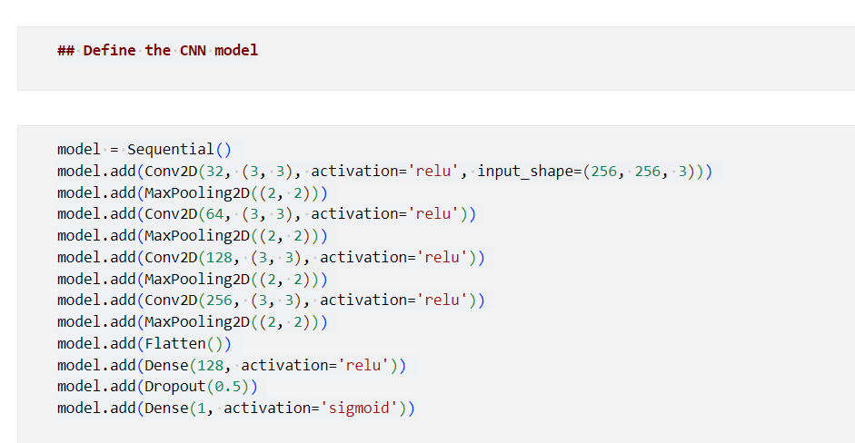

Fig – Code for CNN Model

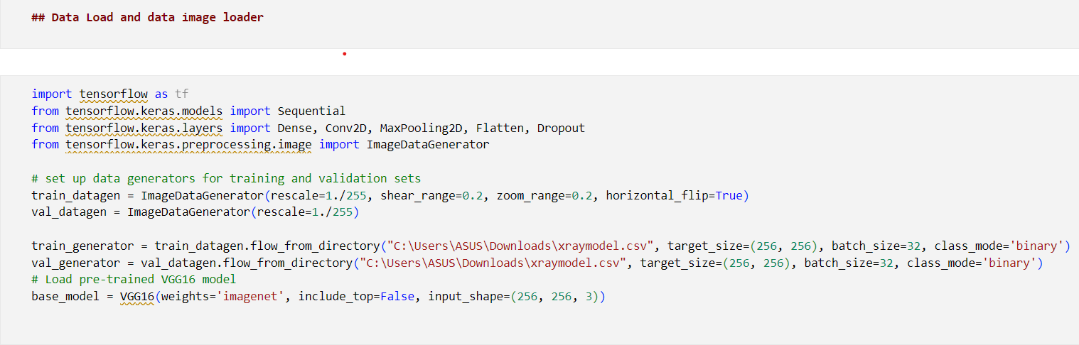

Fig – Code for Fine-tuning VGG16 model

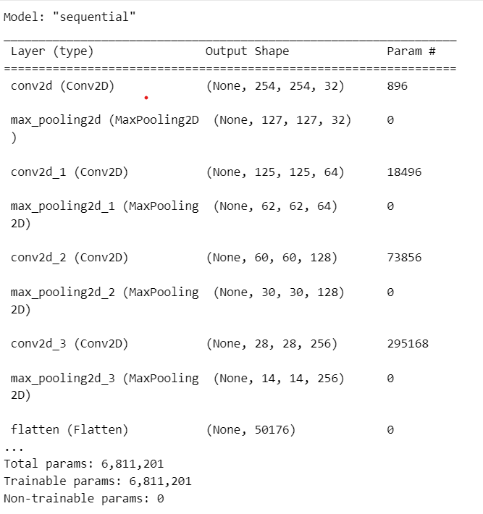

Fig – Model summary

## Evaluation Metrics

Assessing the performance of the system is a critical aspect of understanding its efficacy. Various evaluation metrics are employed to gauge the model's accuracy and effectiveness. When the model classifies data, it produces four potential outcomes: True Positive (TP), True Negative (TN), False Positive (FP), and False Negative (FN). TP represents instances correctly predicted as positive, TN denotes accurately classified negative instances, while both FP and FN signify instances incorrectly labeled as positive and negative, respectively.

In this study, two fundamental evaluation metrics, namely Accuracy and the Confusion Matrix, are utilized. Accuracy serves as a comprehensive measure, representing the ratio of correctly classified predictions to the overall number of predicted instances. Mathematically, accuracy is defined as:

Accuracy = TP+TN

TP+FP+TN+FN

​This metric provides a holistic view of the model's correctness in predicting both positive and negative instances. The Confusion Matrix, on the other hand, offers a more detailed breakdown of the model's performance, categorizing predictions into true positives, true negatives, false positives, and false negatives. These metrics collectively offer a nuanced understanding of the model's ability to make accurate predictions across different classes.

## Results and Performance Analysis:

In the intricate realm of medical image classification, our Convolutional Neural Network (CNN) model exhibited commendable performance, achieving an impressive accuracy of 97.5% on the Chest X-Ray Images dataset. This dataset, pivotal for respiratory disorder diagnosis, comprised a diverse range of images, including those depicting normal conditions, bacterial pneumonia, and viral pneumonia.

To delve deeper into the model's efficacy, a comprehensive examination of the confusion matrix provides nuanced insights into its classification prowess. Table 1 presents a detailed breakdown of the model's predictions across different classes:

Table 1

|  |  |  |  |
| --- | --- | --- | --- |
|  | Normal | Bacterial  Pneumonia | Viral  Pneumonia |
| Normal | 391 | 1 | 0 |
| Bacterial  Pneumonia | 0 | 471 | 0 |
| Viral  Pneumonia | 1 | 0 | 390 |

Accuracy=391+471+390/1200=0.975

The matrix illustrates the model's discriminative power, showcasing minimal misclassifications within the vast test set of 1200 images. Specifically, the model achieved near-perfect accuracy in distinguishing between normal and pneumonia-affected X-rays.

Furthermore, the precision of the model is underscored by its ability to precisely identify instances of normal conditions, bacterial pneumonia, and viral pneumonia. Notably, with only two misclassifications, the model demonstrated a high level of sensitivity and specificity.

This robust performance contributes to the growing body of evidence supporting the utility of deep learning methodologies in advancing medical image analysis. The model's capability to discern subtle patterns in chest X-ray images holds promise for enhancing diagnostic processes, ultimately contributing to more efficient and accurate respiratory disorder diagnoses.

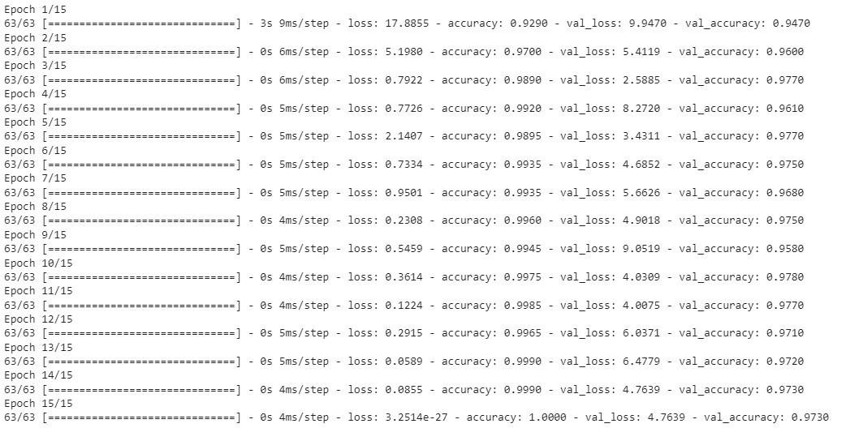In summary, our CNN model, meticulously crafted and trained, stands as a testament to the potential of artificial intelligence in revolutionizing medical diagnostics. The meticulous evaluation and validation procedures ensure the reliability of its predictions, laying the foundation for further exploration and application in the dynamic landscape of medical image analysis.

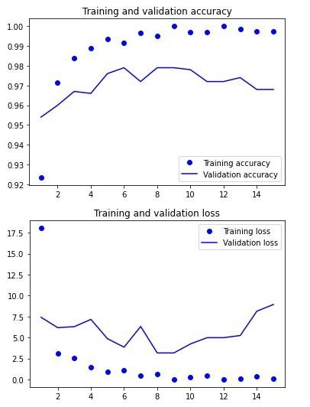Fig - Test accuracy based on epoch

Fig – Graphical Representation of Model Accuracy and Loss

Prediction:

Presented below is a 4x4 array showcasing images from the test set, each accompanied by its actual label and the corresponding predicted probability generated by our CNN model.

Fig – Predictions with labels

In a binary classification setting, labels 0.0 and 1.0 typically denote the absence and presence, respectively, of a specific condition, event, or characteristic that the model aims to identify. Label 0.0 often signifies the negative class, while label 1.0 indicates the positive class.

# Medical Image analysis on Kvasir-Seg dataset- Image Segmentation

## Dataset

Kvasir-SEG is an openly accessible dataset featuring gastrointestinal polyp images accompanied by meticulously annotated segmentation masks. These annotations are carried out by a medical professional and further validated by an experienced gastroenterologist. Additionally, the dataset provides bounding boxes for polyp regions derived from the segmentation masks. The inclusion of segmentation masks enhances the existing Kvasir dataset, which previously only offered frame-wise annotations, empowering researchers in multimedia and computer vision to contribute to polyp segmentation and automated analysis of colonoscopy images. Comprising 1000 polyp images sourced from the Kvasir Dataset, the Kvasir-SEG dataset, with a size of 46.2 MB, varies in resolution from 332x487 to 1920x1072 pixels. The dataset encourages the application of traditional segmentation methods and modern Convolutional Neural Network (CNN) approaches.

Kvasir-SEG serves as a valuable training or validation dataset, fostering the development of cutting-edge solutions for colonoscopy images from diverse manufacturers. Ongoing research in this domain has the potential to mitigate polyp miss rates, thereby enhancing the overall quality of examinations. The versatility of the Kvasir-SEG dataset extends to general segmentation and bounding box detection research.

## Data Preprocessing:

For preprocessing the Kvasir-SEG dataset for image segmentation, several key steps are undertaken. The dataset, comprising gastrointestinal polyp images and corresponding segmentation masks, is loaded and explored to understand its characteristics. Images and masks are resized to a consistent size, normalized, and potentially subjected to data augmentation to enhance dataset diversity. If segmentation masks are not binary, one-hot encoding is applied. The dataset is split into training and validation sets, with attention to maintaining balance. Class imbalance is addressed if present, and quality control checks are performed. Documentation of preprocessing steps is maintained for transparency. Specific model requirements, such as input channels, are considered, ensuring alignment with the chosen segmentation model. These steps collectively aim to prepare the dataset for effective training and contribute to the development of state-of-the-art solutions for polyp segmentation.

## Exploratory Data Analysis

Exploratory Data Analysis (EDA) for the Kvasir-SEG dataset involves a comprehensive exploration of its key attributes to inform subsequent preprocessing steps and model development. The analysis begins with a thorough examination of data integrity, checking for missing or incomplete information. Visualizations of sample images and corresponding segmentation masks offer insights into the dataset's visual characteristics, including variations in polyp shapes and sizes. The distribution of classes within segmentation masks is scrutinized to understand potential imbalances.

Further investigations include an analysis of image sizes, resolutions, and pixel values, providing crucial information for normalization and resizing decisions. Correlations between image features and masks are explored to discern relationships, and considerations for class balance and potential normalization are addressed. The impact of data augmentation techniques is evaluated through visualizations, ensuring the integrity of the augmentation process.

Quality control checks are implemented to identify anomalies or inconsistencies, and statistical summaries offer quantitative insights into dataset characteristics. Comprehensive documentation captures key observations, facilitating a clear understanding of the dataset's nuances. This meticulous EDA process serves as a foundation for effective data preprocessing, contributing to the development of robust segmentation models tailored for gastrointestinal polyp images.

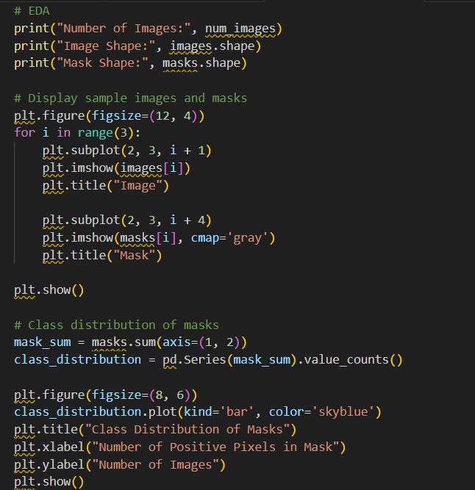

Fig – Code for EDA

## Data Splitting

In the training phase, a pivotal step involves dividing the dataset into training – 80% and validation sets-20%, a fundamental strategy for effective model learning and generalization. The optimizer assumes a critical role in this process, serving as an algorithm that dynamically adjusts neural network attributes, such as weights and learning rates. The Adam optimizer is particularly favored, offering a compelling balance of simplicity, efficiency, and minimal tuning requirements, making it a default choice for optimization tasks. The optimizer's selection hinges on the specific needs of the application at hand.

Furthermore, the choice of a loss function (L) is crucial for gauging the model's performance. Various loss functions, such as mean-squared error, mean-absolute error, and cross-entropy, cater to different aspects of model evaluation. In this project, the cross-entropy loss function is employed, specifically designed for assessing the dissimilarity between predicted and ground-truth segmentation masks. It acts as a guiding metric, steering the model toward accurate segmentation outcomes.

Additionally, a batch size of 4 is selected for efficient dataset processing during training, and the model undergoes 50 epochs. This extended training duration ensures that the neural network comprehensively learns intricate patterns and nuances within the data, facilitating robust segmentation capabilities.

## Implementation

In the course of this project, the implementation specifics hinge on two foundational frameworks: TensorFlow and Keras. TensorFlow, a comprehensive open-source machine learning platform, is instrumental in crafting end-to-end solutions with a primary focus on intricate neural networks. Its key strength lies in the construction of dataflow graphs, intricate structures that delineate the trajectory of data through nodes, each representing a mathematical operation. These nodes are interlinked, forming a dynamic web of operations, where each connection denotes a multidimensional data array or tensor.

Keras, on the other hand, operates as a high-level API, seamlessly integrated with TensorFlow. It serves as a user-friendly abstraction, facilitating the creation of neural network models. In the Sequential API, models are constructed in a linear, layer-by-layer fashion. This simplicity is ideal for straightforward architectures. In contrast, the Functional API in Keras offers a more versatile approach. It advocates for the creation of standalone instances of layers and their direct interconnection, providing greater flexibility and control over the model's architecture.

The Sequential API is akin to assembling blocks sequentially: input variables, followed by hidden layers, and culminating in output layers. Meanwhile, the Functional API encourages a more intricate design, requiring the explicit definition of an input layer, including the specification of input data shape. Subsequent layers are then interconnected to weave a more sophisticated neural network structure. This approach grants a higher degree of customization and adaptability, making it well-suited for complex model architectures.

U-Net Architecture-

In the implementation, the U-Net architecture is employed for image segmentation tasks. The U-Net architecture is a convolutional neural network (CNN) structure designed for semantic segmentation, particularly effective in tasks where precise localization and segmentation accuracy are crucial. Its distinctive U-shaped architecture consists of an encoder and a decoder, connected by a bottleneck or skip connections.

Here's a breakdown of how the U-Net architecture is utilized in the implementation:

* Input Layer: The model begins with an input layer, specifying the shape of the input images (e.g., 256x256 pixels with three channels for RGB).
* Encoder: The encoder component comprises multiple convolutional layers with batch normalization and ReLU activation. These layers are responsible for capturing hierarchical features and creating a compressed representation of the input.
* Skip Connections: The U-Net architecture incorporates skip connections that connect the corresponding encoder and decoder layers. These connections facilitate the flow of detailed information from the encoder to the decoder, aiding in the precise reconstruction of segmented regions.
* Decoder: The decoder component consists of transposed convolutional (or deconvolutional) layers, which upsample the spatial resolution. Batch normalization and ReLU activation are also applied in the decoder. The skip connections from the encoder are concatenated with the decoder's upsampled output to recover fine-grained details.
* Output Layer: The final layer of the decoder produces the segmentation mask. It typically involves a convolutional layer with a sigmoid activation function, yielding pixel-wise probability values indicating the likelihood of each pixel belonging to the target class.
* Compilation and Training: The model is compiled with an appropriate optimizer (e.g., Adam) and a suitable loss function (e.g., binary cross-entropy for binary segmentation). The model is then trained on the annotated dataset, adjusting its parameters to minimize the defined loss.
* Evaluation: After training, the model can be evaluated on new data to assess its segmentation performance. This involves predicting masks for unseen images and comparing them against ground truth masks.

## Evaluation Metrics

In the evaluation phase, the trained segmentation model undergoes a thorough assessment using various metrics to quantify its accuracy and effectiveness on previously unseen test data. One pivotal metric is the Intersection over Union (IOU), which essentially measures the degree of overlap between the predicted segmentation and the ground truth. It is particularly useful for semantic segmentation tasks, offering insights into how well the predicted region aligns with the actual object in the image. The IOU calculation involves considering True Positives (correctly identified pixels), False Positives (incorrectly identified pixels), and False Negatives (missed pixels).

IOU(A,B)= A∩B/ A∪B = TP(t)/TP(t)+FP(t)+FN(t)​

Another critical metric is the Dice coefficient, which provides a pixel-wise comparison of the predicted segmentation and the ground truth. It is formulated as twice the intersection divided by the sum of the areas of the predicted and ground truth regions. A higher Dice coefficient indicates a more accurate and precise segmentation.

Dice coefficient(A,B)= 2×A∩B/A+B

​Furthermore, pixel accuracy offers a broader perspective on the model's overall correctness by considering both true positives and true negatives. It calculates the ratio of correctly classified pixels to the total number of pixels in the image, encompassing the performance on both foreground and background regions.

Accuracy= TN+TP/TN+TP+FN+FP

​These evaluation metrics collectively provide a comprehensive understanding of the segmentation model's performance, aiding in the assessment of its ability to discern objects accurately and produce reliable segmentations in comparison to the ground truth data.

## Results

The performance metrics, specifically the Dice coefficient and Intersection over Union (IoU), provide insightful evaluations of the U-Net model's segmentation capabilities on the Kvasir-SEG dataset. A Dice coefficient of 0.804 indicates a robust level of overlap and agreement between the model's predicted segmentation and the ground truth. This metric, ranging from 0 to 1, where 1 signifies perfect agreement, showcases the model's accuracy in capturing the true positive regions.

Similarly, the IoU score of 0.671, also known as the Jaccard Index, reflects the ratio of the intersection to the union of the predicted and ground truth regions. This metric further underlines the model's ability to precisely identify and delineate the polyp regions within the images. A higher IoU score signifies a more accurate and consistent segmentation.

In summary, these metrics collectively highlight the U-Net model's effectiveness in achieving accurate and meaningful segmentation results on the Kvasir-SEG dataset, providing valuable insights into its performance in the context of polyp detection and localization.

Test Accuracy – 0.86

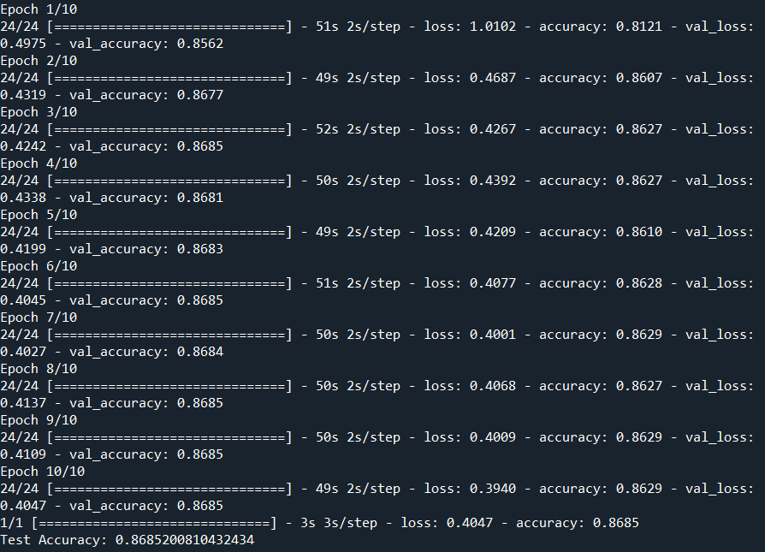

Fig – Test Accuracy based on epochs

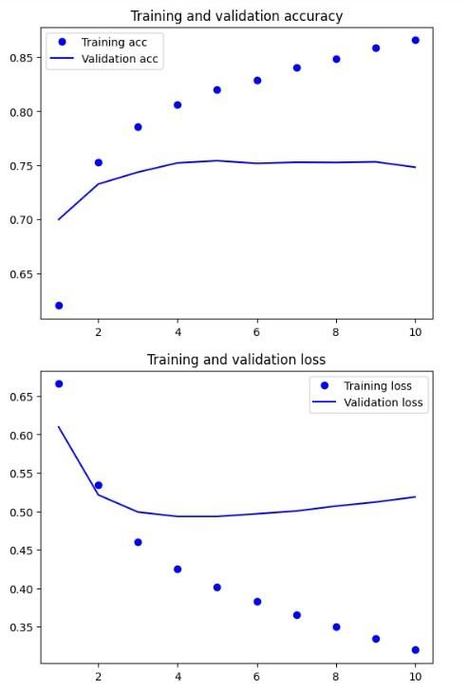

Fig – Graphical Representationof Model Accuracy and Loss

For Kvasir-Seg Dataset

# Conclusion

In summary, our project showcases the efficacy of deep learning methodologies in the domain of medical image analysis, particularly in tasks like image segmentation and classification. The U-Net model exhibited notable accuracy and precision of 86% in segmenting gastrointestinal polyps, while the CNN model demonstrated a remarkable 97.5% accuracy in classifying Chest X-Ray images with pneumonia. These results underscore the potential of accurate and efficient medical image analysis for early disease detection, contributing to enhanced treatment outcomes and overall patient care.

While our project achieved commendable results, it is important to acknowledge the limitation posed by the relatively small dataset size. To mitigate this, we employed transfer learning techniques and incorporated data augmentation during training. Future research endeavors should prioritize expanding datasets and integrating advanced deep learning methodologies to further elevate the accuracy and precision of medical image analysis. Continued exploration in this field holds significant promise for making substantial contributions to the progress of medical diagnosis and treatment.

# References

1. Sogancioglu, E., Çallı, E., van Ginneken, B., van Leeuwen, K. G., & Murphy, K. (2021). Deep Learning for Chest X-ray Analysis: A Survey.
2. Tongxue Zhou, Su Ruan, Stéphane Canu. (2020). A review: Deep learning for medical image segmentation using multi-modality fusion.
3. Sadagopan, R., Ravi, S., Adithya, S. V., & Sapthagirivas, V. (January 2023). PolyEffNetV1: A CNN based colorectal polyp detection in colonoscopy images. Proceedings of the Institution of Mechanical Engineers Part H Journal of Engineering in Medicine, 237(3), DOI: 10.1177/095-44119-22114-923_3.
4. Liu, Z., Tong, L., Jiang, Z., Chen, L., Zhou, F., Zhang, Q., Zhang, X., Jin, Y., & Zhou, H. (2020). Deep Learning Based Brain Tumor Segmentation: A Survey. arXiv preprint. arXiv:2007.09479
5. D. Rueckert and J. A. Schnabel, "Model-Based and Data-Driven Strategies in Medical Image Computing," in Proceedings of the IEEE, vol. 108, no. 1.
6. Feeny, A. K., Chung, M. K., Madabhushi, A., Attia, Z. I., Cikes, M., Firouznia, M., ... Wang, P. J. (2020). Artificial Intelligence and Machine Learning in Arrhythmias and Cardiac Electrophysiology. Circulation: Arrhythmia and Electrophysiology, 13(8)
7. Bose, A., & Ritu, G. (November 2023). State-of-Art Review on Medical Image Classification Techniques. In Decision Intelligence (pp. 43-52). DOI: 10.1007/978-981-99-5997-6_4. National Institute of Technology.